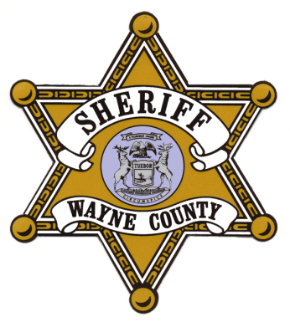
Raphael Washington

Wayne County Sheriff

FREEDOM OF INFORMATION ACT REQUEST FORM
Date Submitted:
Requestor’s Information:
Name: _______ _______________________________________________________________
Street Address: ____________________ ______________________________________________
City, State, Zip: _______________________________________________________________________
Telephone: _____________________ ______________________________________________
Email: _______________________________________________________________________
Fax: _______________________________________________________________________
Information Requested:
Type of Document: ______________________________________________________________________
Name of Document: ______________________________________________________________________
Incident # if known: ______________________________________________________________________
Soc. Security# (optional): _____________________________________________________________________
Location of Incident _____________________________________________________________________
Mail or Fax To: Cynthia Golson
Department Supervisor/FOIA Officer
Wayne County Sheriff’s Office
FOIA Department
4747 Woodward
Detroit, MI 48201
(313) 833-0562
Fax: (313) 224-6169

